**Short communication – Research in Veterinary Science**

**Assessment of nasal wipe and swab sample collection for in house RT-qPCR Influenza A virus in swine herds**

Francisco Elias Vendruscolo1, Caroline Pissetti2, Eduardo de Freitas Costa3, Janice Reis Ciacci Zanella4

1Programa de Pós-Graduação em Produção e Sanidade Animal (PPGPSA), Instituto Federal Catarinense, IFC, Campus Concórdia, Concórdia, SC, Brazil, 2 Centro de Diagnóstico de Sanidade Animal, CEDISA, Concórdia, SC, Brazil, 3Department of Epidemiology, Bioinformatics and Animal Models, Wageningen Bioveterinary Research, Lelystad, the Netherlands, 4Embrapa Suínos e Aves, Concórdia, SC, Brazil.

**Abstract**

Influenza A virus (IAV) is an important pathogen in Brazilian swine herds, and monitoring the viral circulation is essential to control and reduce the transmission. For this reason, estimating the prevalence at the individual level of pigs is still crucial to assess the level of infection in herds. In this way, two sample collection methodologies were compared in herds in southern Brazil for the detection of IAV by RT-qPCR: swab and wipe nasal. A Bayesian latent class model (BLCM) was set for two tests and two populations. The nasal swab has on average, higher sensitivity and specificity values compared to the nasal wipe method. Both the swab and wipe presented are more specific (higher than 95% for both) than sensitive. The sensitivity for wipe was lower than the swab 84.14% and 87.15%, respectively. This may occur because detection of virus depends on the excretion period of the agent, and it is common for the wipe nasal to have more inhibition for detection by RT-PCR. Despite the wipe sample collection loose both sensitivity and specificity, compared with swab, it is a useful tool for IAV detection in pig herds, and the decision about the use of both techniques should be based on the tradeoff between its performance limitations and feasibility in routine monitoring.

**Short Communication**

Influenza A virus (IAV) is the most relevant pathogen in the porcine respiratory disease complex (PRDC) in Brazil (Rech et al., 2018). The infection with IAV in pigs is typically self-limiting, clinically characterized by fever, loss of appetite, and cough. However, these symptoms cause weight loss, which significantly affects the productivity of growing pigs and the reproductive performance of breeding sows, in addition to being a gateway for co-infections. Consequently, it brings an increase in costs due to treatments for secondary infections, reducing the profitability of the herd (Fablet et al., 2018).

From a public health perspective, IAVs are a concern virus given the potential for reassortments and the emergence of pandemic strains. Since the pandemic H1N1 (H1N1pdm09) virus in 2009, multiple incursions from humans into swine have been reported worldwide and have led to substantial IAV genetic and antigenic diversity in swine populations (Ciacci-Zanella et al., 2015; Junqueira et al., 2023; Nelson et al., 2015; Tochetto et al., 2023). Because IAV is endemic and causes minimal mortality in infected swine, the World Organization for Animal Health (WOAH, founded as OIE) has not classified swine flu as a notifiable disease or reportable. However, controlling and reducing the transmission of pathogens and preventing diseases are goals routinely set in the modern swine industry, leading to a batter control of secondary infections and monitoring circulating strains as zoonotic potential.

Therefore, estimating prevalence at the individual pig level is still crucial to assess the level of infection in the herds. Although the samplings from the nose with a deep swab are the sample of choice (Van Reeth and Vincent, 2019), they require an intense interaction with the pigs, consequently, it is more manpower and time-consuming. Other studies discuss the possibility of using alternative methods of sampling for respiratory diseases, such as aggregated samples (de Lara et al., 2022; Osemeke et al., 2022; Romagosa et al., 2012), and collecting the nose secretion with a wipe could be an alternative for IAV detection in pig level (Nolting et al., 2015).

We aimed to assess the performance of the reverse-transcription polymerase chain reaction real time (RT-qPCR) designed to detect the matrix M of the IAV (Zhang and Harmon, 2014) using nasal swabs and nasal wipes as methods of sampling collection in pigs raised in a vertical integration system in three sites. For the swab nasal, sterile polyester swabs were used, which were insert the swab into the nasal cavity in a dorsal‐medial direction, making a circular motion to gently collect as much nasal secretion as possible (Van Reeth and Vincent, 2019) and conditioned in MEM (Minimum Essential Medium) transport medium supplemented with antibiotics, amphotericin B and BSA (bovine serum albumin) until arrival at the laboratory. Nasal softness using nasal wipes were used hydrophilic cotton gauze previously sterilized and rubbed on the surface of the animal's snout (Nolting et al., 2015) and subsequently packed in a transport medium in the same way.

All pig farms are located in the same region in southern Brazil (within a 35-km radius around the point 27° 14′ 3″ S, 52° 1′ 43″ W). The animals of the study were from the growth and finishing phase, comprising individuals between 70 and 80 days of life. The genetics used on the farms are the company's own and the lots housed comprise male and female animals (mixed batches). The samples were taken in two moments previously known by distinct prevalence: 30 pigs in winter (July), and 80 pigs in summer (December), hereafter called population 1 and population 2, respectively.

We used a Bayesian latent class model (BLCM) set for two tests and two populations. Since the diagnostic test is the same (i.e., RT-qPCR assays targeting the matrix M), the latent class to be assessed is the presence/absence of the IAV in pig’s nose. The paired results of the tests are crossed in a 2x2x2 table in which each cell counts the combination of positive and negative in each population and each sampling collection, entering the model as realizations of a multinomial distribution:

$x\left[1:8\right]\sim Multinomial(p\left[1:8\right],n)$. (1)

where *n* is the total number of samples in each population. Each one of the $p[1:8]$ represents the probability of positive or negative status (1 or 0) in RT-qPCR from swab and wipe ($Px_{swab,wipe}:\{Px_{0,0},Px_{1,0,}Px_{0,1},Px_{0,0}\}$) in each population $j$:

$p\left[1:8\right]=\left\{\begin{aligned}P\left(x_{1,1}\right)=π_{j}∙Se\left(x_{1}\right)∙Se\left(x_{2}\right)+(1-π_{j})∙(1-Sp\left(x_{1}\right))∙(1-Sp\left(x_{2}\right)) \\ P\left(x_{1,0}\right)=π_{j}∙\left(1-Se\left(x_{1}\right)\right)∙Se\left(x_{2}\right)+(1-π_{j})∙Sp\left(x_{1}\right)∙(1-Sp\left(x_{2}\right)) \\ P\left(x_{0,1}\right)=π_{j}∙Se\left(x_{1}\right)∙(1-Se\left(x_{2}\right))+(1-π_{j})∙(1-Sp\left(x_{1}\right))∙Sp\left(x_{2}\right) \\ P\left(x_{0,0}\right)=π_{j}∙\left(1-Se\left(x_{1}\right)\right)∙\left(1-Se\left(x_{2}\right)\right)+(1-π_{j})∙Sp\left(x_{1}\right)∙Sp\left(x_{2}\right)\end{aligned}\right.$, (2)

where $Se$, and $Sp$ stands for the sensitivity and specificity, and $π_{j=1}, π_{j=2}$ are the prevalences in the population 1 and 2, respectively. We choose using with weakly informative beta(2,1) priors for sensitivity, specificity and flat priors beta(1,1) for both prevalences. The model was run in four chains, each with 30,000 iterations, burning the first 15,000 samples and thinning each three samples. The model was run in library “runjags” (Denwood, 2016) in R (Core Team, 2023).

In population 1, most of the samples (22) were positive for both swab and wipe. On the other hand, in population 2, the majority of the samples were negative for both swab and wipe (Table 1).

Table 1 – Combination of the positive and negative results of the RT-qPCR from samples collected with swabs and wipes in two different pig population.

|  |  |  |  |  |
| --- | --- | --- | --- | --- |
|  | **Population 1** | | **Population 2** | |
| **Wipe**  **Swab** | **+** | **-** | **+** | **-** |
| **+** | 22 | 4 | 0 | 0 |
| **-** | 3 | 1 | 3 | 77 |

The BLMC model converged well (see supplementary material for the model diagnostics) and the prevalence in population 1 was 95.53% [85.8% - 100% credible interval (CrI)]; the prevalence in population 2 was 1% [0% - 4.3% CrI]. Despite being a disease that occurs all year, IAV has historically been characterized as a seasonal disease, associated with dramatic temperature fluctuations, and decreased ventilation (Janke, 2013). In Brazil, the winter period, as well as population 1, presents more cases clinical of sick animals. However, the aim of the study is not to accurately estimate the prevalence in both population but using the discrepancy in the between-population prevalences to enhance the identifiability of the model in assessing the sensitivity and specificity (Hui and Walter, 1980). Consequently, the results observed here are limited to assess the true prevalence in this population of fattening pigs, but exclusively dedicates to estimate the sensitivity and specificity of RT-qPCR in recovering IAV when collecting samples using swabs or wipes.

Both samples’ techniques had higher specificity than sensitivity, but the swab has, on average, bigger values for sensitivity and specificity compared with the wipe method. Also, the sensitivities had larger credible intervals (CrI) range compared with the specificities (Figure 1).

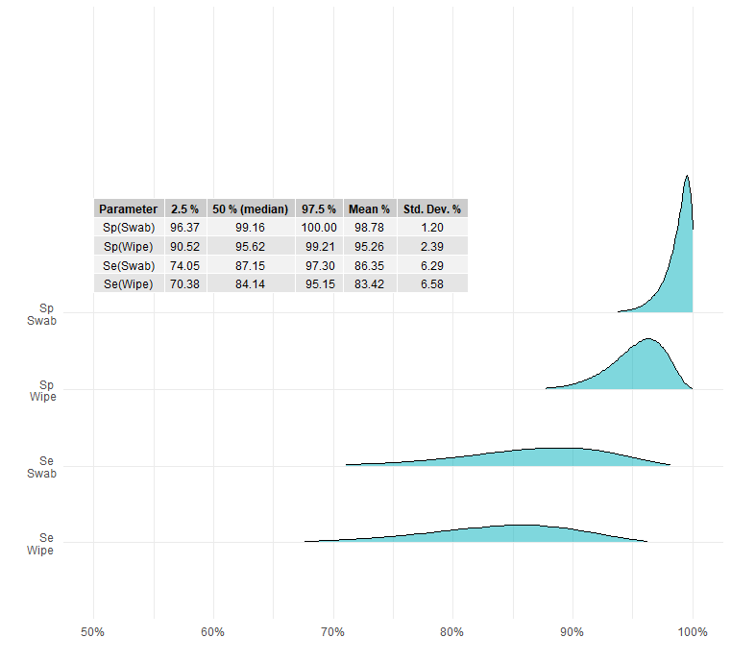

Figure 1 – Density distributions of the combination of the posterior four chains simulated in the model.

The high specificity observed in both samples was expected, since the RT-qPCR used was specifically designed to amplify the conserved region of the IAV matrix M and recommended by several official organizations (Zhang and Harmon, 2014). On the other hand, the sensitivity of the test may be impaired at the time of collection, since the animal must excrete the AIV, that is occur until approximately the 8th day after exposure (Vincent et al., 2014). Furthermore, the quality of the sample collected also affects the sensitivity of the test. In this case, the nasal tissue presents more limitations, as it is more common for the animal to have contact with environmental debris (i.e., bedding, feed, manure, etc.) and for it to be deposited in its nose, consequently included in the sample. These contaminants can inhibit RT-PCR amplification (Nolting et al., 2015), reducing the sensitivity.

We observed that the sample collection via nasal swab performs better than wipe for IAV detection in pigs. However, the decision of the sampling technique should consider the balance between the diagnostics performance and the feasibility of taking samples in daily bases AIV monitoring in pig herds.

**References**

Ciacci-Zanella, J.R., Schaefer, R., Gava, D., Haach, V., Cantão, M.E., Coldebella, A., 2015. Influenza A virus infection in Brazilian swine herds following the introduction of pandemic 2009 H1N1. Vet Microbiol 180. https://doi.org/10.1016/j.vetmic.2015.08.021

de Lara, A.C., Garrido-Mantilla, J., Lopez-Moreno, G., Yang, M., Barcellos, D.E.S.N., Torremorell, M., 2022. Effect of pooling udder skin wipes on the detection of influenza A virus in preweaning pigs. Journal of Veterinary Diagnostic Investigation 34. https://doi.org/10.1177/10406387211039462

Denwood, M.J., 2016. runjags: An R package providing interface utilities, model templates, parallel computing methods and additional distributions for MCMC models in JAGS. J Stat Softw 71. https://doi.org/10.18637/jss.v071.i09

Fablet, C., Rose, N., Grasland, B., Robert, N., Lewandowski, E., Gosselin, M., 2018. Factors associated with the growing-finishing performances of swine herds: An exploratory study on serological and herd level indicators. Porcine Health Manag 4. https://doi.org/10.1186/s40813-018-0082-9

Hui, S.L., Walter, S.D., 1980. Estimating the Error Rates of Diagnostic Tests. Biometrics 36. https://doi.org/10.2307/2530508

Janke, B.H., 2013. Clinicopathological features of swine influenza. Curr Top Microbiol Immunol 370. https://doi.org/10.1007/82-2013-308

Junqueira, D.M., Tochetto, C., Anderson, T.K., Gava, D., Haach, V., Cantão, M.E., Baker, A.L.V., Schaefer, R., 2023. Human-to-swine introductions and onward transmission of 2009 H1N1 pandemic influenza viruses in Brazil. Front Microbiol 14. https://doi.org/10.3389/fmicb.2023.1243567

Nelson, M.I., Viboud, C., Vincent, A.L., Culhane, M.R., Detmer, S.E., Wentworth, D.E., Rambaut, A., Suchard, M.A., Holmes, E.C., Lemey, P., 2015. Global migration of influenza A viruses in swine. Nat Commun 6. https://doi.org/10.1038/ncomms7696

Nolting, J.M., Szablewski, C.M., Edwards, J.L., Nelson, S.W., Bowman, A.S., 2015. Nasal wipes for influenza a virus detection and isolation from swine. Journal of Visualized Experiments 2015. https://doi.org/10.3791/53313

Osemeke, O.H., de Freitas Costa, E., Almeida, M.N., Trevisan, G., Ghosh, A.P., Silva, G.S., Linhares, D.C.L., 2022. Effect of pooling family oral fluids on the probability of PRRSV RNA detection by RT-rtPCR. Prev Vet Med 206. https://doi.org/10.1016/j.prevetmed.2022.105701

Rech, R.R., Gava, D., Silva, M.C., Fernandes, L.T., Haach, V., Ciacci-Zanella, J.R., Schaefer, R., 2018. Porcine respiratory disease complex after the introduction of H1N1/2009 influenza virus in Brazil. Zoonoses Public Health 65. https://doi.org/10.1111/zph.12424

Romagosa, A., Gramer, M., Joo, H.S., Torremorell, M., 2012. Sensitivity of oral fluids for detecting influenza A virus in populations of vaccinated and non-vaccinated pigs. Influenza Other Respir Viruses 6. https://doi.org/10.1111/j.1750-2659.2011.00276.x

Core Team, R., 2023. R Core Team 2023 R: A language and environment for statistical computing. R foundation for statistical computing. https://www.R-project.org/. R Foundation for Statistical Computing.

Tochetto, C., Junqueira, D.M., Anderson, T.K., Gava, D., Haach, V., Cantão, M.E., Vincent Baker, A.L., Schaefer, R., 2023. Introductions of Human-Origin Seasonal H3N2, H1N2 and Pre-2009 H1N1 Influenza Viruses to Swine in Brazil. Viruses 15. https://doi.org/10.3390/v15020576

Van Reeth, K., Vincent, A.L., 2019. Influenza Viruses, in: Diseases of Swine. Wiley, pp. 576–593. https://doi.org/10.1002/9781119350927.ch36

Vincent, A.L., Lager, K.M., Anderson, T.K., 2014. A brief introduction to influenza a virus in swine. Methods in Molecular Biology 1161. https://doi.org/10.1007/978-1-4939-0758-8_20

Zhang, J., Harmon, K.M., 2014. RNA extraction from swine samples and detection of influenza a virus in swine by real-time RT-PCR. Methods in Molecular Biology 1161. https://doi.org/10.1007/978-1-4939-0758-8_23

**Supplementary material**

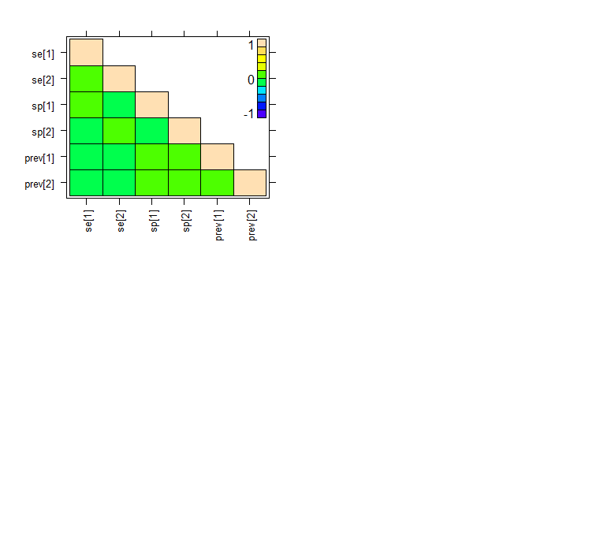

Table S1- Heatmap of the correlation between the posterior chains simulated in the model.

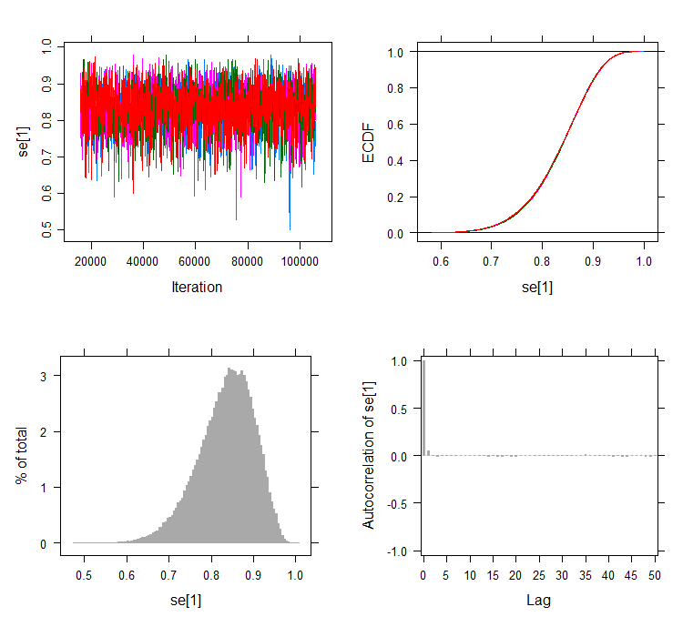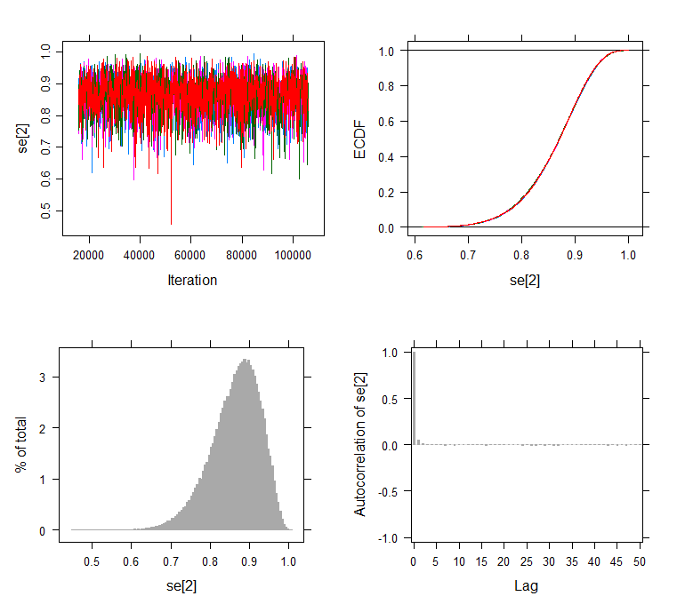

Table S2 – Trace plot and distribution of the four posterior chains of the sensitivities (1: Wipe, 2: Swab).

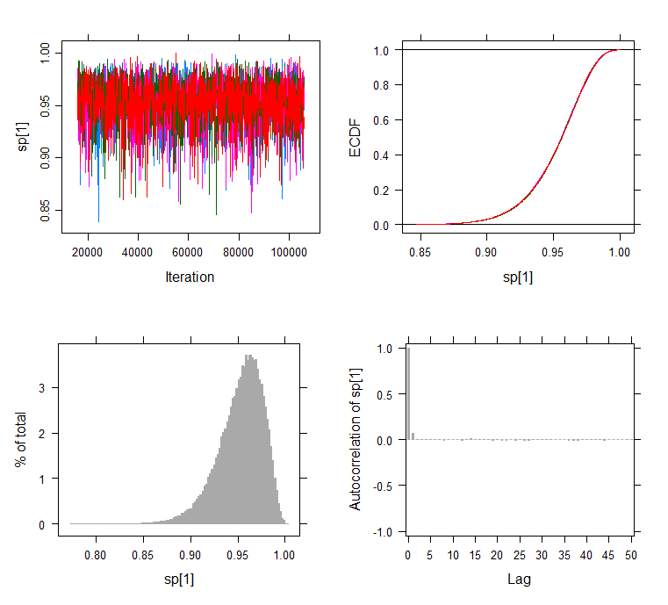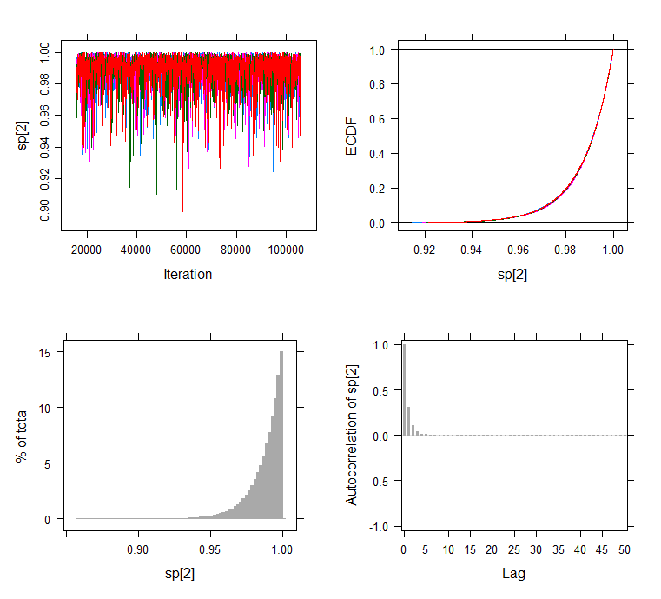

Table S3 – Trace plot and distribution of the four posterior chains of the specificities (1: Wipe, 2: Swab).

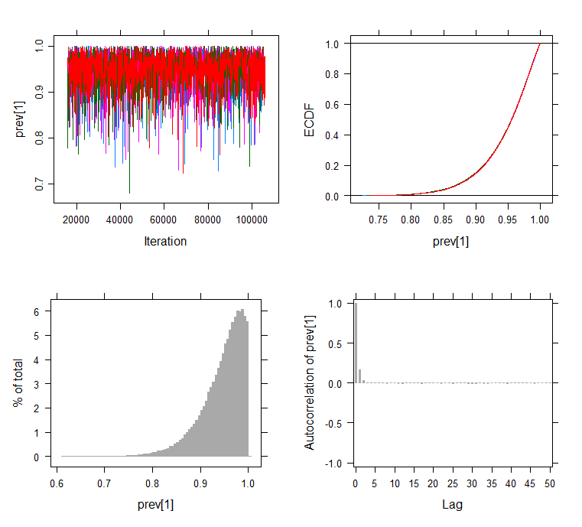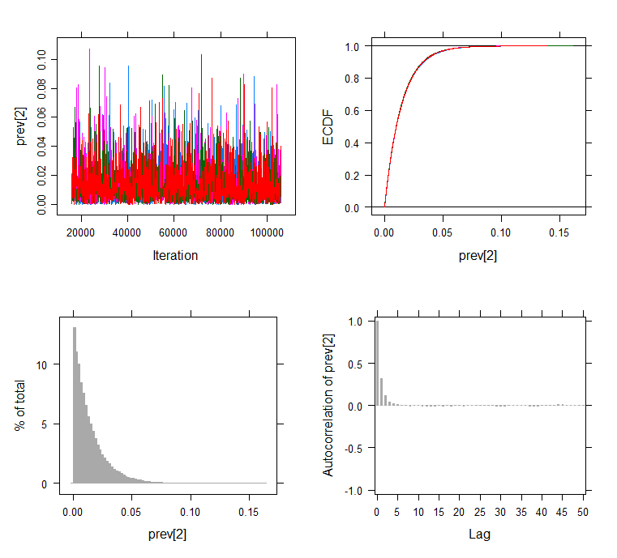

Table S4 – Trace plot and distribution of the four posterior chains of the prevalence (1: population 1, 2: Population 2).